ESP32-radio building instructions
This document describes the building instruction of ESP32 Internet radio. It is assumed that the PCB for this radio, available through PCBWay, is used.
The PCB can be used for several configurations of the hardware. For every variety a chapter is included in this document.
The 3 varieties are:
- Radio with software MP3 decoding and SPDIF (optical) output only.
- Radio with software MP3 decoding and line output.
- Radio with software MP3 decoding, amplifier and speaker output.
- Radio with hardware MP3 decoding and line output.
- Radio with hardware MP3 decoding, amplifier and speaker output.

Within these varieties, there are option like a TFT display and a rotary encoder. See chapter 6.
The print (top side) looks like this:
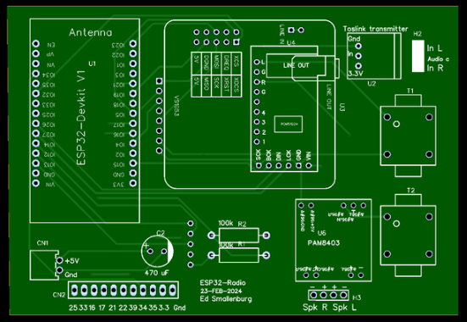
There is a small error in the print. The texts near the 3 holes of the Toslink transmitter (U2) are wrong. “In” should be “3.3V” and “3.3V” should be “In”.

The bottom side of the print looks like this:

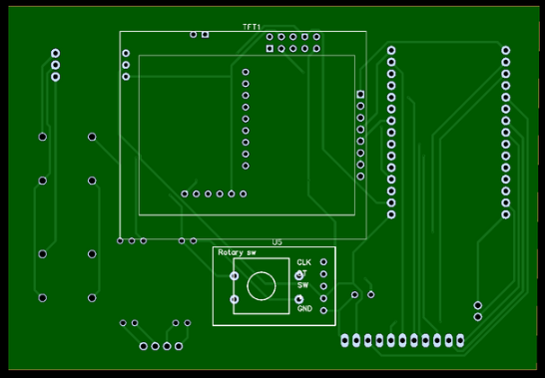
The display and/or the rotary encoder should be mounted here.

Radio with software MP3 decoding and SPDIF (optical) output only.
This is the simplest version. In fact there are only 2 active parts: the ESP32 and a Toslink optical transmitter. There is no tone control. You need an external stereo amplifier with a optical (Toslink) input. The software can only decode MP3 and AAC data streams, but they are most commonly used.

Used components.
- PBC. Available through PCBway.
- ESP32 devkit V1. Available here.
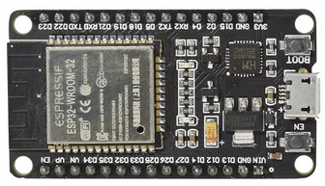
- Note that the pin layout must correspond with the picture above.
- A Toslink transmitter. Available here. You may also need a Toslink cable to your amplifier.
- An electrolytic capacitor, 470 µF (220 µF or 100 µF will also work).
- A 2 pin connector witch cable to your 5 Volt power supply. For example this. Note that the distance between the pins is 2.54 mm.
The pins for +5 (red) and ground (black) may be reversed. Use a sharp pin to modify if necessary.
You may also directly solder the power lines to the print of course.
- Female headers to mount the ESP32. 2 headers of 15 pins are needed. You may also use a 40 pin header and cut it into 2 x 15 pins. See here.
- 2 x 100 k resistors. Not needed if you are not interested in reading the battery voltage.
- Optional: a TFT display and or a rotary encoder. See chapter 6.

Mounting instructions.
- Prepare 2 15 pins female headers and solder them to the top side of the PCB. The position is marked with “ESP32-Devkit V1”. It helps if you put the headers on the ESP32 first in order to make the perfect alignment.
- Mount the capacitor on the top side of the PCB. The position is marked “C2”. Align the minus side of the capacitor, marked with a white band to the right. The PCB is also marked on the right side.
- Mount the power cable (and connector) on the top side of the PCB in the lower left corner. The position is marked “CN1”.
- The print will now look like this:
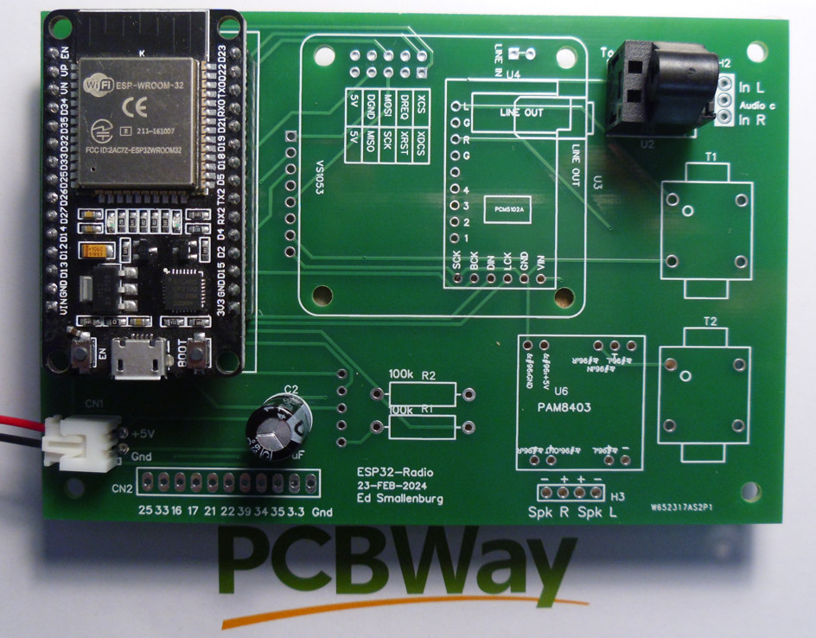
- Optional: add a TFT display and/or a rotary encoder. See chapter 6.

Testing.
Edit the config.h file. Set FIXEDWIFI (near line 17) to your SSID/PASSWORD of your WiFi network.
Define “DEC_HELIX_SPDIF” near line 24, out-comment the other “DEC_xxxx” definitions.
If the display is mounted, define “BLUETFT” (near line 31) and out-comment the other display definitions. Otherwise, define “DUMMYTFT” and out-comment the other display definitions.

Upload the data directory to SPIFFS using “Upload Filesystem Image” in the PlatformIO menu:
and upload the compiled program using “Upload” in the same menu.

Activate the serial monitor and reset the ESP32. Observe the debug output. Make a note of the IP address (search for line containing “IP:”), for example “192.168.2.33”. Start your Internet browser and go to this address.
Go to the configuration page and press the “Default” button. Edit the configuration here, make sure that “pin_i2s_spdif = 15” is defined and the definitions for “pin_vs_*” and “pin_i2s_*” are commented out or removed.
If the display is connected: make sure the lines with “pin_tft_cs = 2” and “pin_tft_dc = 4” are defined.
If the rotary encoder is mounted: make sure the lines with “pin_enc_clk = 12”, “pin_enc_dt = 14” and “pin_enc_sw = 13” are defined.

Press the “Save” button and after that press the “Restart” button”.
The red light of the LED should be visible all the time. Connect the radio to an external amplifier using a Toslink cable.

Radio with software MP3 decoding and line output.
The MP3 conversion is done by software in the ESP32. A Digital to analog converter is used to deliver the analog output to a headphone or to an external amplifier. There is no tone control. The software can only decode MP3 and AAC data streams, but they are most commonly used.

Used components.
- PBC. Available through PCBway.
- ESP32 devkit V1. Available here.
- Note that the pin layout must correspond with the picture above.
- PCM5102A module. Available here.

- An electrolytic capacitor, 470 µF (220 µF or 100 µF will also work).
- A 2 pin connector witch cable to your 5 Volt power supply. For example this. Note that the distance between the pins is 2.54 mm.
The pins for +5 (red) and ground (black) may be reversed. Use a sharp pin to modify if necessary.
You may also directly solder the power lines to the print of course.
- Female headers to mount the ESP32. 2 headers of 15 pins are needed. You may also use a 40 pin header and cut it into 2 x 15 pins. See here.
- Male headers to mount the PCM5102A. 15 pins are needed. You may use a 40 pin header and cut it into fitting pieces. See here.
- 2 x 100 k resistors. Not needed if you are not interested in reading the battery voltage.
- Optional: add a TFT display and/or a rotary encoder switch. See chapter 6.

Mounting instructions.
- Prepare 2 15 pins female headers and solder them to the top side of the PCB. The position is marked with “ESP32-Devkit V1”. It helps if you put the headers on the ESP32 first in order to make the perfect alignment.
- Mount the capacitor on the top side of the PCB. The position is marked “C2”. Align the minus side of the capacitor, marked with a white band to the right. The PCB is also marked on the right side.
- Mount the power cable (and connector) on the top side of the PCB in the lower left corner. The position is marked “CN1”.
- Mount the PCM5102A on the top side of the PCB. The position is marked “PCM5102A”. Use female headers (6 and 9 pins) on the side of the PCB and male headers on the side of the PCM5102A.. It helps to put the headers on the module first in order to make the perfect alignment.
- The print will now look like this:
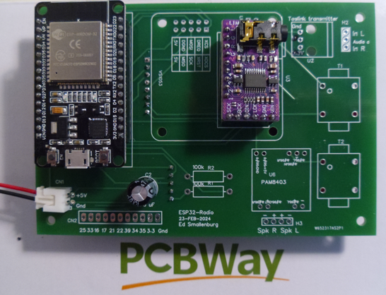
- Optional: add a TFT display and/or a rotary encoder. See chapter 6.
- Important note: In some cases, pin 3 of the PCM5102A module may not be left floating. The effect is that there will be no sound or very choopy. So it is advised to make a small modifications to the PCM5102A module if not already present. Connect the pin “3” on the back side of the module to “H”, pin “4” to “L”, pin “1” to “L” and pin 2 to “L”. See the picture:
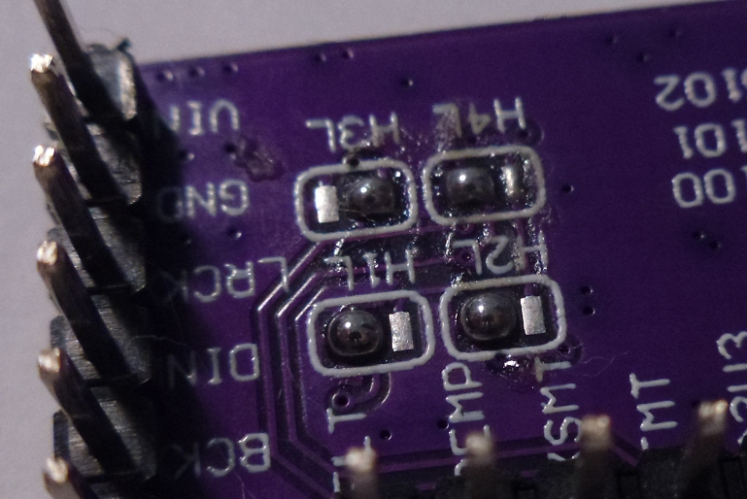

Testing.
Edit the config.h file. Set FIXEDWIFI (near line 17) to your SSID/PASSWORD of your WiFi network.
Define “DEC_HELIX” near line 25, out-comment the other “DEC_xxxx” definitions.
If the display is mounted, define “BLUETFT” (near line 31) and out-comment the other display definitions. Otherwise, define “DUMMYTFT” and out-comment the other display definitions.
Upload the data directory to SPIFFS using “Upload Filesystem Image” in the PlatformIO menu:
and upload the compiled program using “Upload” in the same menu.
Activate the serial monitor and reset the ESP32. Observe the debug output. Make a note of the IP address (search for line containing “IP:”), for example “192.168.2.33”. Start your Internet browser and go to this address.
Go to the configuration page and press the “Default” button. Edit the configuration here, make sure that “pin_i2s_spdif = 15” is defined.
If the display is connected: make sure the lines with “pin_tft_cs = 2” and “pin_tft_dc = 4” are defined.
If the rotary encoder is mounted: make sure the lines with “pin_enc_clk = 12”, “pin_enc_dt = 14” and “pin_enc_sw = 13” are defined.
Press the “Save” button and after that press the “Restart” button”.

Radio with software MP3 decoding, amplifier and speaker output.
The MP3 conversion is done by software in the ESP32. A Digital to analog converter is used to deliver the analog output to a headphone or to an external amplifier. There is no tone control. The software can only decode MP3 and AAC data streams, but they are most commonly used.

Used components.
- PBC. Available through PCBway.
- ESP32 devkit V1. Available here.
- Note that the pin layout must correspond with the picture above.
- A PCM5102A module. Available here.

- A PAM8403 amplifier and 2 audio transformers (600/600 Ohm). Available here and here.
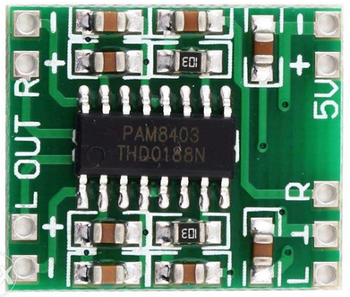
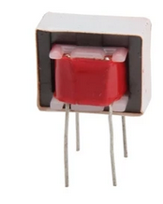
- An electrolytic capacitor, 470 µF (220 µF or 100 µF will also work).
- A 2 pin connector witch cable to your 5 Volt power supply. For example this. Note that the distance between the pins is 2.54 mm.
The wires for +5 (red) and ground (black) may be reversed. Use a sharp pin to modify if necessary.
You may also directly solder the power lines to the print of course.
- Female headers to mount the ESP32. 2 headers of 15 pins are needed. You may also use a 40 pin header and cut it into 2 x 15 pins. See here.
- Male headers to mount the PCM5102A. 15 pins are needed. You may use a 40 pin header and cut it into fitting pieces. See here.
- 2 x 100 k resistors. Not needed if you are not interested in reading the battery voltage.
- Optional: a TFT display and/or a rotary encoder switch. See chapter 6.

Mounting instructions.
- Prepare 2 15 pins female headers and solder them to the top side of the PCB. The position is marked with “ESP32-Devkit V1”. It helps if you put the headers on the ESP32 first in order to make the perfect alignment.
- Mount the capacitor on the top side of the PCB. The position is marked “C2”. Align the minus side of the capacitor, marked with a white band to the right. The PCB is also marked on the right side.
- Mount the power cable (and connector) on the top side of the PCB in the lower left corner. The position is marked “CN1”.
- Mount the PCM5102A on the top side of the PCB. The position is marked “PCM5102A”. Use female headers (6 and 9 pins) on the side of the PCB and male headers on the side of the PCM5102A.. It helps to put the headers on the module first in order to make the perfect alignment.
- Mount the PAM8403 module. The position on the print is marked “PAM8403”. The print will look like this
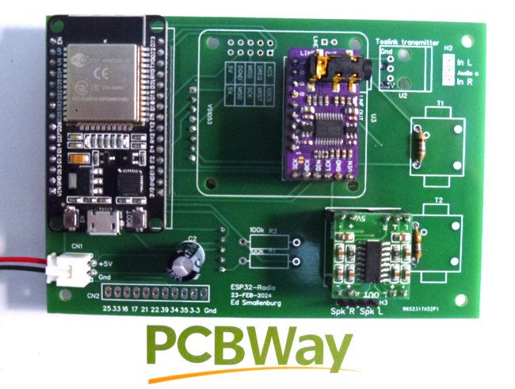
- Note the 2 resistors on the right side of the PCB. Normally these are not required, but when the output volume is too high (distorsion), you can decrease it by placing 2 x180 Ohm resistors on the secondary side of T1 and T2.
- Optional: Add a TFT display and/or a rotary encoder. See chapter 6.
- Important note: In some cases, pin 3 of the PCM5102A module may not be left floating. So it is advised to make a small modifications to the PCM5102A module. Connect the pin “3” on the back side of the module to “H” and the other 3 pins to “L”. See the picture:
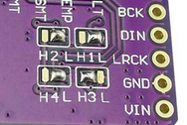

Testing.
Edit the config.h file. Set FIXEDWIFI (near line 17) to your SSID/PASSWORD of your WiFi network.
Define “DEC_HELIX” near line 25, out-comment the other “DEC_xxxx” definitions.
If the display is mounted, define “BLUETFT” (near line 31) and out-comment the other display definitions. Otherwise, define “DUMMYTFT” and out-comment the other display definitions.

Upload the data directory to SPIFFS using “Upload Filesystem Image” in the PlatformIO menu:
and upload the compiled program using “Upload” in the same menu.

Activate the serial monitor and reset the ESP32. Observe the debug output. Make a note of the IP address (search for line containing “IP:”), for example “192.168.2.33”. Start your Internet browser and go to this address.
Go to the configuration page and press the “Default” button. Edit the configuration here, set “pin_i2s_bck = 15”, “pin_i2s_din = 26” and “pin_i2s_lck”.
If the display is connected: make sure the lines with “pin_tft_cs = 2” and “pin_tft_dc = 4” are defined.
If the rotary encoder is mounted: make sure the lines with “pin_enc_clk = 12”, “pin_enc_dt = 14” and “pin_enc_sw = 13” are defined.

Press the “Save” button and after that press the “Restart” button”.

The output level of the PCM5102A may be a bit too high for a PAM5102. Solder 2 resistors of 12 Ohm on the PCM5102A module, one resistor between pin “G” and pin “L” and one between pin “G” and “R”.

Radio with hardware MP3 decoding and line output.
The MP3 conversion is done by hardware. A VS1053 module is used to deliver the analog output to a headphone or to an external amplifier.

Used components.
- PBC. Available through PCBway.
- ESP32 devkit V1. Available here.
- Note that the pin layout must correspond with the picture above.
- A VS1053 module. Available here.
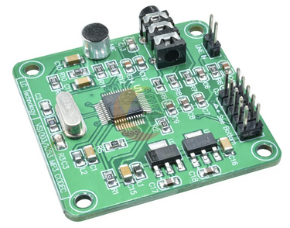
- An electrolytic capacitor, 470 µF (220 µF or 100 µF will also work).
- A 2 pin connector witch cable to your 5 Volt power supply. For example this. Note that the distance between the pins is 2.54 mm.
The pins for +5 (red) and ground (black) may be reversed. Use a sharp pin to modify if necessary.
You may also directly solder the power lines to the print of course.
- Female headers to mount the ESP32 and the VS1053. You may use 40 pin headers and cut them to be fitted. See here.
- 2 x 100 k resistors. Not needed if you are not interested in reading the battery voltage.
- Optional: a TFT display and/or a rotary encoder switch. See chapter 6.

Mounting instructions.
- Prepare 2 15 pins female headers and solder them to the top side of the PCB. The position is marked with “ESP32-Devkit V1”. It helps if you put the headers on the ESP32 first in order to make the perfect alignment.
- Mount the capacitor on the top side of the PCB. The position is marked “C2”. Align the minus side of the capacitor, marked with a white band to the right. The PCB is also marked on the right side.
- Mount the power cable (and connector) on the top side of the PCB in the lower left corner. The position is marked “CN1”.
- Mount the VS1053 upside down on the top side of the PCB. The position is marked “VS1053”. Use female headers (2 x 5 pins and one 2 pin header) on the side of the PCB. It helps to put the headers on the module first in order to make the perfect alignment.
- The print will now look like this:
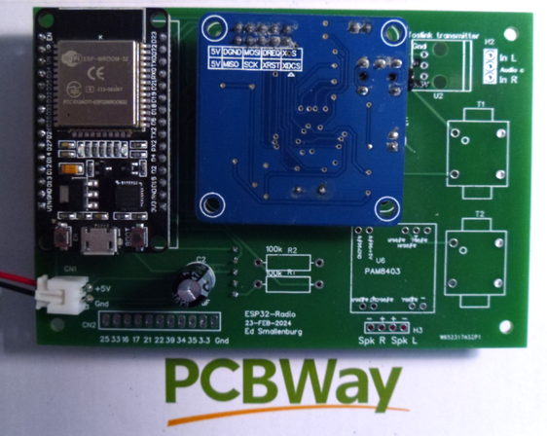
- Optional: mount a TFT display and/or a rotary encoder. See chapter 6.

Testing.
Edit the config.h file. Set FIXEDWIFI (near line 17) to your SSID/PASSWORD of your WiFi network.
Define “DEC_VS1053” near line 22, out-comment the other “DEC_xxxx” definitions.
If the display is mounted, define “BLUETFT” (near line 31) and out-comment the other display definitions. Otherwise, define “DUMMYTFT” and out-comment the other display definitions.

Upload the data directory to SPIFFS using “Upload Filesystem Image” in the PlatformIO menu:
and upload the compiled program using “Upload” in the same menu.

Activate the serial monitor and reset the ESP32. Observe the debug output. Make a note of the IP address (search for line containing “IP:”), for example “192.168.2.33”. Start your Internet browser and go to this address.
Go to the configuration page and press the “Default” button. Edit the configuration here, make sure that “pin_i2s_spdif = 15” is defined.
If the display is connected: make sure the lines with “pin_tft_cs = 2” and “pin_tft_dc = 4” are defined.
If the rotary encoder is mounted: make sure the lines with “pin_enc_clk = 12”, “pin_enc_dt = 14” and “pin_enc_sw = 13” are defined.

Press the “Save” button and after that press the “Restart” button”.

Radio with hardware MP3 decoding, amplifier and speaker output.
The MP3 conversion is done by hardware. A VS1053 module is used to deliver the analog output to a headphone or to an external amplifier.

Used components.
- PBC. Available through PCBway.
- ESP32 devkit V1. Available here.
- Note that the pin layout must correspond with the picture above.
- A VS1053 module. Available here.
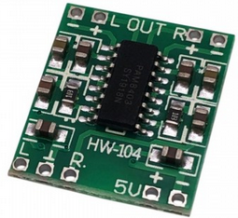
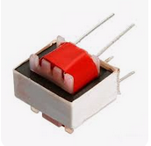
- A PAM8403 amplifier and 2 audio transformers (600/600 Ohm). Available here and here.
- An electrolytic capacitor, 470 µF (220 µF or 100 µF will also work).
- A 2 pin connector witch cable to your 5 Volt power supply. For example this. Note that the distance between the pins is 2.54 mm.
The pins for +5 (red) and ground (black) may be reversed. Use a sharp pin to modify if necessary.
You may also directly solder the power lines to the print of course.
- Female headers to mount the ESP32 and the VS1053. You may use 40 pin headers and cut them to be fitted. See here.
- 2 x 100 k resistors. Not needed if you are not interested in reading the battery voltage.
- Optional: a TFT display and/or a rotary encoder. See chapter 6.

Mounting instructions.
- Prepare 2 15 pins female headers and solder them to the top side of the PCB. The position is marked with “ESP32-Devkit V1”. It helps if you put the headers on the ESP32 first in order to make the perfect alignment.
- Mount the capacitor on the top side of the PCB. The position is marked “C2”. Align the minus side of the capacitor, marked with a white band to the right. The PCB is also marked on the right side.
- Mount the power cable (and connector) on the top side of the PCB in the lower left corner. The position is marked “CN1”.
- Mount the VS1053 upside down on the top side of the PCB. The position is marked “VS1053”. Use female headers (2 x 5 pins and one 2 pin header) on the side of the PCB. It helps to put the headers on the module first in order to make the perfect alignment.
- Mount the PAM8403 and the 2 audio transformers on the top side of the print. The transformers are necessary because the audio common of the VS1053 is not at ground level.
- The print will now look like this:
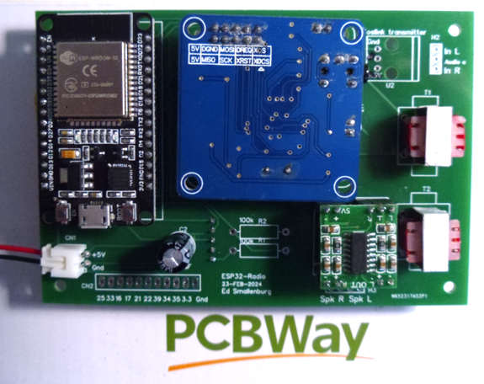
- Prepare a cable with a 3.5 audio connector like this:
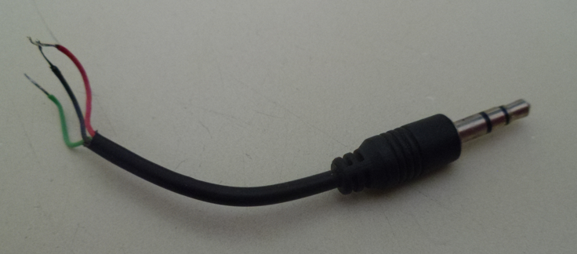
- Solder the cable to the top side of the print, position is marked “H2”. The common wire is usually black and should be connected to “Audio c”. The audio plug must be put in the 3.5 mm of the VS1053.
- Optionally mount the TFT display and/or the rotary switch. See chapter 6.
- The print looks like this:
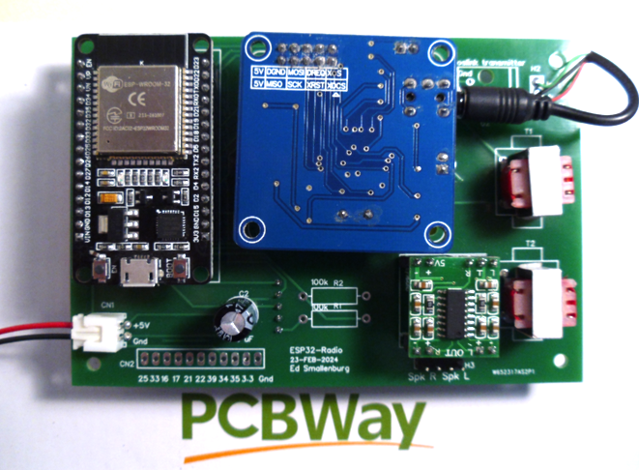

Testing.
Edit the config.h file. Set FIXEDWIFI (near line 17) to your SSID/PASSWORD of your WiFi network.
Define “DEC_VS1053” near line 22, out-comment the other “DEC_xxxx” definitions.
If the display is mounted, define “BLUETFT” (near line 31) and out-comment the other display definitions. Otherwise, define “DUMMYTFT” and out-comment the other display definitions.

Upload the data directory to SPIFFS using “Upload Filesystem Image” in the PlatformIO menu:
and upload the compiled program using “Upload” in the same menu.

Activate the serial monitor and reset the ESP32. Observe the debug output. Make a note of the IP address (search for line containing “IP:”), for example “192.168.2.33”. Start your Internet browser and go to this address.
Go to the configuration page and press the “Default” button. Edit the configuration here, make sure that “pin_i2s_spdif = 15” is defined.
If the display is connected: make sure the lines with “pin_tft_cs = 2” and “pin_tft_dc = 4” are defined.
If the rotary encoder is mounted: make sure the lines with “pin_enc_clk = 12”, “pin_enc_dt = 14” and “pin_enc_sw = 13” are defined.

Press the “Save” button and after that press the “Restart” button”.

Optional components.

Optional TFT display.
The TFT display is available here. The PCB is designed for this display. If you want to use a different one, you may use extension wires to connect it. Use an 8 pin female header. Mount the display at the back side of the print. The position is marked “TFT1”. Use an 8 pin female header. Also mount the 2 100k resistors marked “R1” and “R2”. This allows to measure the input voltage and display the result on the display.

Optional rotary encoder.
A rotary encoder switch, type KY-040 is available here. The 5 pins are not very handy if you want to mount the decoder on the print. You may want to replace them with straight male pins and mount them on the other side of the encoder module. Mount the encoder on the back side of the print using a 5 pin female header. You may want to use extension wires like this if you want to mount the encoder in a different position.
Without the rotary switch, the radio can be controlled by web interface and/or MQTT only.

After these 2 steps, the back side of the print looks like this:

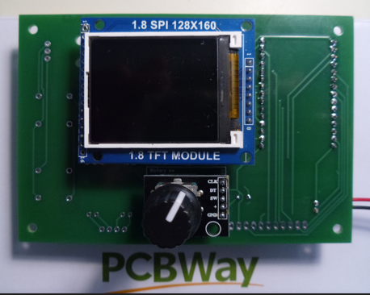
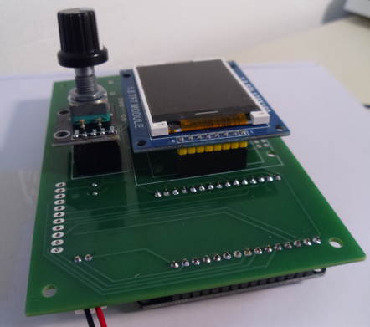
Note: On the rotary encoder module, there are 3 pull-up resistors. These are not necessary as the 3 ESP32 inputs already have a pull-up. In fact, the resistors may introduce some problems during program upload. So it may be better to remove them from the module.

Optional IR receiver.
With an IR receiver, the radio can be controlled by almost any IR remote controller. You have link the IR codes to radio functions in the config page of the web interface. You can find the codes in the serial debug output when you press a key on your remote control.
An IR receiver, type VS1838B can be found here.
Prepare the VS1838B and a 3 pins female header like this:
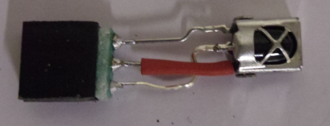
Mount this module on the top side of the print:
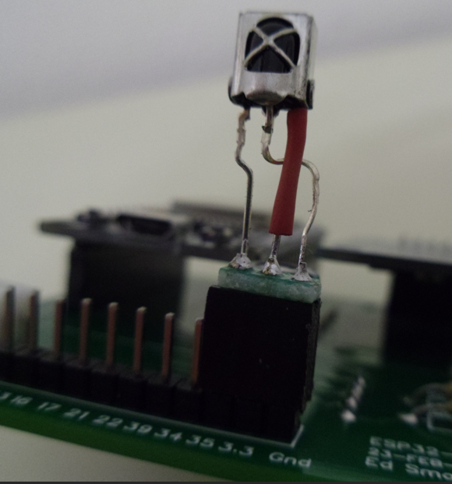
In this case pin 35 is used for the signal line of the receiver. Be sure that “pin_ir = 35” is defined in the config page of the web interface.

